Pokhara University

Level: Bachelor | Semester – Fall | Year : 2010
Programme: BE |  | Full Marks: 100
Course: Digital Signal Processing |  | Pass Marks: 45
 |  | Time : 3hrs.

Candidates are required to give their answers in their own words as far as practicable.
The figures in the margin indicate full marks.

Attempt all the questions.

 | - What are the basic elements of the digital signal processing? Explain the set-up with the help of a block diagram.  - Consider a signal 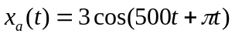is sampled 400 times per second to obtain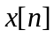. Determine whether or not the signals 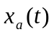and is periodic. In case a signal is periodic, specify its fundamental period.  - Evaluate 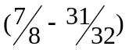 in two's complement using 6-bit notation. | 5  5  5
 | - Determine the range of 'a' for which the LTI system with impulse response  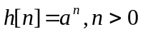is stable.  - The impulse response of LTI system is 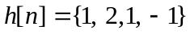.  Determine the response of the system to the input signal  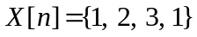  - Check the system is 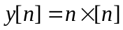for time invariance. | 5  8  2
 | - Determine the Z-transform of the signal 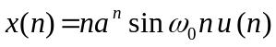  - Determine the causal signal x(n) having the Z-transform 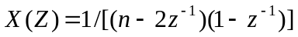  - Define one sided Z-transform. Write the properties of one-sided Z-transform. | 5  5  5
 | - Determine the circular convolution of the sequences.  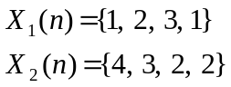  - Show that the relationship of DFT to the Z-transform. | 7  8
 | - Draw the lattice ladder structure for the following system;  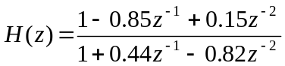. Is this system stable.  - Obtain the parallel form realization of the following IIR digital filter transfer function: 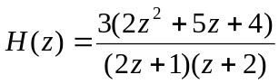 | 8  7
 | - Briefly explain FIR filter design by Windowing method.  - Design a low-pass discrete-time filter by applying impulse invariance method to an appropriate Butterworth filter. The specifications for the filter are:  Pass-band attenuation 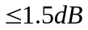 Pass-band edge frequency = 1 KHz.  Stop-band attenuation 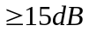 Stop-band edge frequency = 2.5 KHz  Sampling frequency = 10KHz | 6  9
 | Write short notes on: (Any Two)  - Bit serial arithmetic  - FIR & IIR  - System properties | 2×5

